Project Planning Phase
Project Planning Template (Product Backlog, Sprint Planning, Stories, Story points)
Date | 15 February 2026
Team ID | SWTID-2026-1597
Project Name | AI Fit Track API – Personalized Fitness Tracking with AI-Powered Insights
Maximum Marks | 5 Marks

Product Backlog, Sprint Schedule, and Estimation (4 Marks)
Sprint | Functional Requirement (Epic) | User Story Number | User Story / Task | Story Points | Priority | Team Members
Sprint-1 | Registration | USN-1 | As a user, I can register by entering my name, email and password. | 5 | High | Nithya Sri S
Sprint-1 | Registration | USN-2 | As a user, I cannot register with a duplicate email. | 3 | High | Nithiksha J
Sprint-1 | Login | USN-3 | As a user, I can log in and receive a JWT token. | 8 | High | Nithya Sree KS
Sprint-1 | Project Setup | — | Initialise Node.js project, configure environment, connect MongoDB. | 4 | High | Nivetha P
Sprint-2 | Workout Log | USN-4 | As a user, I can add a workout entry. | 5 | High | Nithya Sri S
Sprint-2 | Workout Log | USN-5 | As a user, I can view, update and delete my workouts. | 8 | High | Nithiksha J
Sprint-2 | Goals | USN-6 | As a user, I can set and update fitness goals. | 7 | Medium | Nithya Sree KS
Sprint-3 | Statistics | USN-7 | As a user, I can view weekly/monthly stats. | 8 | High | Nivetha P
Sprint-3 | AI Insights | USN-8 | As a user, I can get an AI progress summary. | 7 | High | Nithya Sri S
Sprint-3 | AI Insights | USN-9 | As a user, I get personalised recommendations with fallback mode. | 5 | Medium | Nithiksha J
Sprint-4 | Administration | USN-10 | As an admin, I can manage user accounts. | 5 | Medium | Nithya Sree KS
Sprint-4 | Monitoring | USN-11 | As an admin, I can check API health. | 3 | Low | Nivetha P
Sprint-4 | Testing | — | API testing in Postman, bug fixing and documentation. | 12 | High | All members

Project Tracker, Velocity & Burndown Chart: (4 Marks)
Sprint | Total Story Points | Duration | Sprint Start Date | Sprint End Date (Planned) | Story Points Completed (as on Planned End Date) | Sprint Release Date (Actual)
Sprint-1 | 20 | 6 Days | 16 Feb 2026 | 21 Feb 2026 | 20 | 21 Feb 2026
Sprint-2 | 20 | 6 Days | 23 Feb 2026 | 28 Feb 2026 | 20 | 28 Feb 2026
Sprint-3 | 20 | 6 Days | 02 Mar 2026 | 07 Mar 2026 | 20 | 07 Mar 2026
Sprint-4 | 20 | 6 Days | 09 Mar 2026 | 14 Mar 2026 | 20 | 14 Mar 2026

Velocity:
Total story points = 80 over 4 sprints of 6 days each.
Velocity per sprint = 80 / 4 = 20 story points per sprint.
Average Velocity (AV) = sprint velocity / sprint duration = 20 / 6 ≈ 3.33 story points per day.
Burndown Chart:
The burndown chart plots story points remaining against working days. The team stayed close to the ideal line and completed all 80 points by the end of Sprint-4.
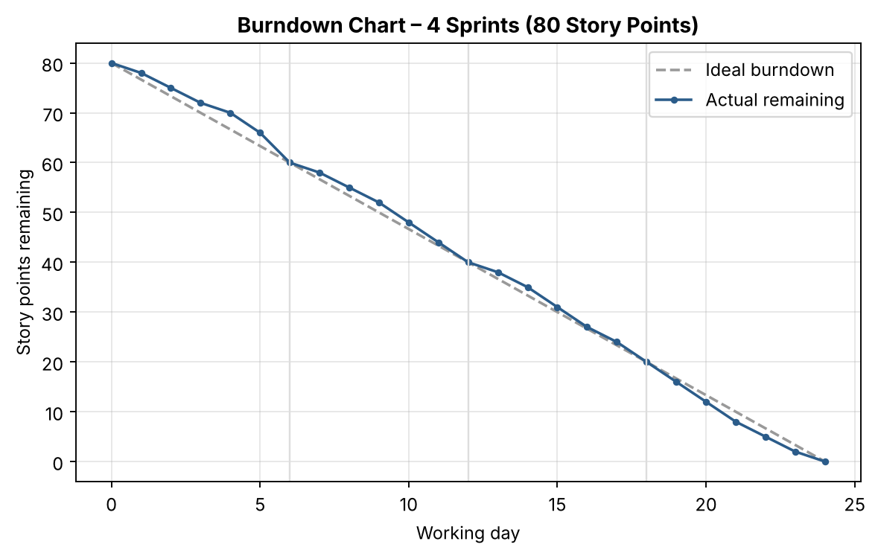
Figure 1: Burndown chart for AI Fit Track API
Milestones
- M1: Architecture and requirement finalisation completed.
- M2: Project scaffolding and environment setup completed.
- M3: Authentication and Workout Log CRUD modules functional.
- M4: Stats aggregation and Gemini AI modules functional.
- M5: All APIs tested successfully via Postman.
- M6: Final documentation and demonstration completed.

